CS 340 README
About the Project
The Animal Shelter project is a full-stack dashboard application with a standalone backend Data Access Object (DAO) that communicates with the database via a MongoDB client. It deploys its own middleware following the Model-View-Controller (MVC) paradigm. The application facilitates the viewing of different animals and filtering by specific rescue mission criteria. The project aims to provide a simple, intuitive visual interface to quickly analyze data while allowing for robust data manipulation, such as sorting, pagination, and filtering.

Motivation
This project acts as an exploratory application to demonstrate secure, object-oriented data management utilizing Python, MongoDB, and Dash. Developed as part of the CS 340 Client/Server Development course, it emphasizes industry-standard practices, including exception handling, clean architectural separation between the database and application logic, and a highly cohesive frontend interface.

Tools used
- MongoDB: All database functionalities are provided by MongoDB. MongoDB serves as the "Model" component of the MVC pattern. Using the PyMongo driver allows for Python-native, dictionary-based queries that closely mirror mongosh syntax. While the interface is encapsulated via the AnimalShelter DAO, querying is made highly efficient. For example, filtering requires simply passing a dictionary populated with our required values (e.g., {"animal_type": "Dog"}), which is far more streamlined than writing raw SQL strings.
- Dash: Dash provides the web server and the reactive application framework. It serves as both the "View" (the UI layout) and the "Controller" (the callbacks that process user input). It enabled the creation of an instantaneous, responsive application without requiring JavaScript. Furthermore, this backend-driven approach mitigates frontend data manipulation risks, as the data is securely refreshed from the backend on every request.
- Dash Bootstrap Components (DBC): While raw Dash components can look visually outdated, coupling Dash with Bootstrap via DBC allowed for the creation of a modern, elegant, and highly usable interface with minimal custom CSS.
- Plotly Express (Pyplot): Drawing data graphics typically requires vast amounts of boilerplate code. Plotly Express simplified this process, allowing for the generation of interactive, highly customizable charts with just a few lines of code.
- Pandas: While the raw BSON data provided by MongoDB reflects a Python list of dictionaries, it must be decoded into a manipulatable format for the data table and charts. Pandas bridges this gap by converting the raw data into a DataFrame, gracefully handling edge cases and making data manipulation seamless.

Requirements
- Python 3(https://www.python.org/downloads/)
- MongoDB: Download the server for testing from https://www.mongodb.com/try/download/community or use Mongo Atlas.
- PyMongo: (pip install pymongo) The official MongoDB driver for Python. It enables interaction with any MongoDB database with minimal configuration.
- Jupyter Notebook: (Optional) Recommended for testing the module in an interactive environment.
- Dash: (pip install dash<3.0.4). Newer versions can cause problems.
- Dash Bootstrap Components: (pip install dash-bootstrap-components)
- Plotly: (pip install plotly)
- Pandas: (pip install pandas)

How to Run (Getting Started)
Follow these steps to reproduce the dashboard:
- Database Configuration: Ensure your MongoDB server is running. The application targets a database named `aac` containing an animals collection.
- Environment Setup: Ensure Python 3 is installed along with the required dependencies installable by (`pip install -r requirements.txt`)
- Authentication: The database requires a secure user account. Use `mongosh` or MongoDB Compass to create a user with `readWrite` privileges restricted to the `aac` database. Update the backend DAO script with these credentials.
- Launch the Application: Open the Juypter notebook file (`ProjectTwoDashboard.ipynb`), and run the file. Please note that it must be in the same directory as Python_CRUD_Module.py.
- Access the Dashboard: Once the local server starts, open a web browser and navigate to the localhost address provided in the terminal output (typically `http://127.0.0.1:8050/` or ` http://localhost:8050`). The dashboard will instantly render, pulling fresh data securely from the backend.

Tests
To ensure the resilience and accuracy of the architectural separation between the database and application logic, rigorous manual testing was conducted:
- Backend Validation: The MongoDB DAO was tested in an isolated Jupyter Notebook environment. Direct CRUD operations were executed against the aac database to verify that the PyMongo cursor conversions and exception handling behaved gracefully without crashing the application.
- Frontend Testing: Manual system testing was performed on the Dash framework. This included verifying that the Plotly Express charts and data tables updated dynamically and synchronously when specific rescue mission filters (e.g., Water Rescue, Mountain Rescue) were toggled via user input. Layout responsiveness was also validated using the Dash Bootstrap Components grid system.

Screenshots
Functionality
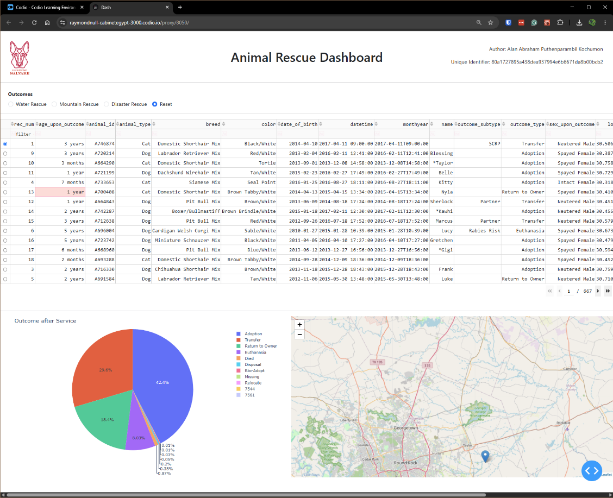
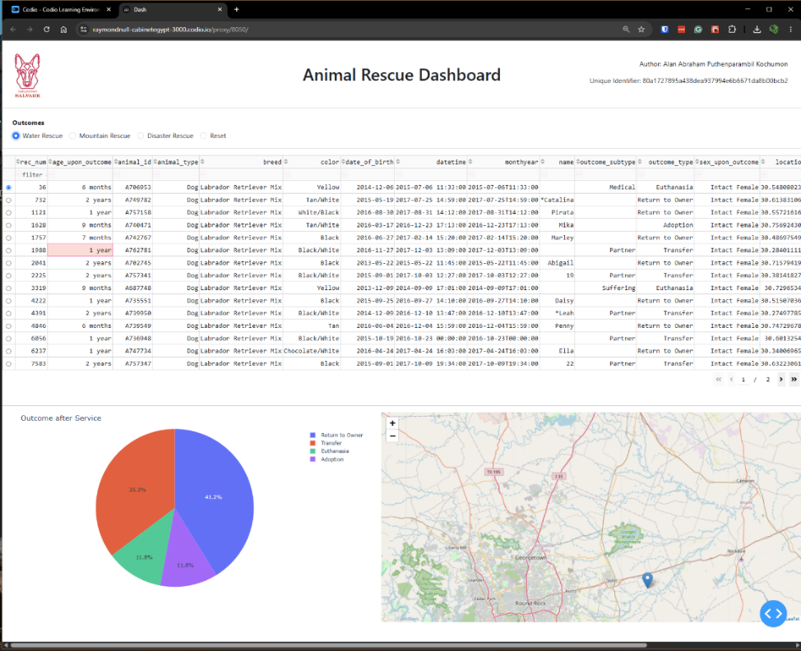
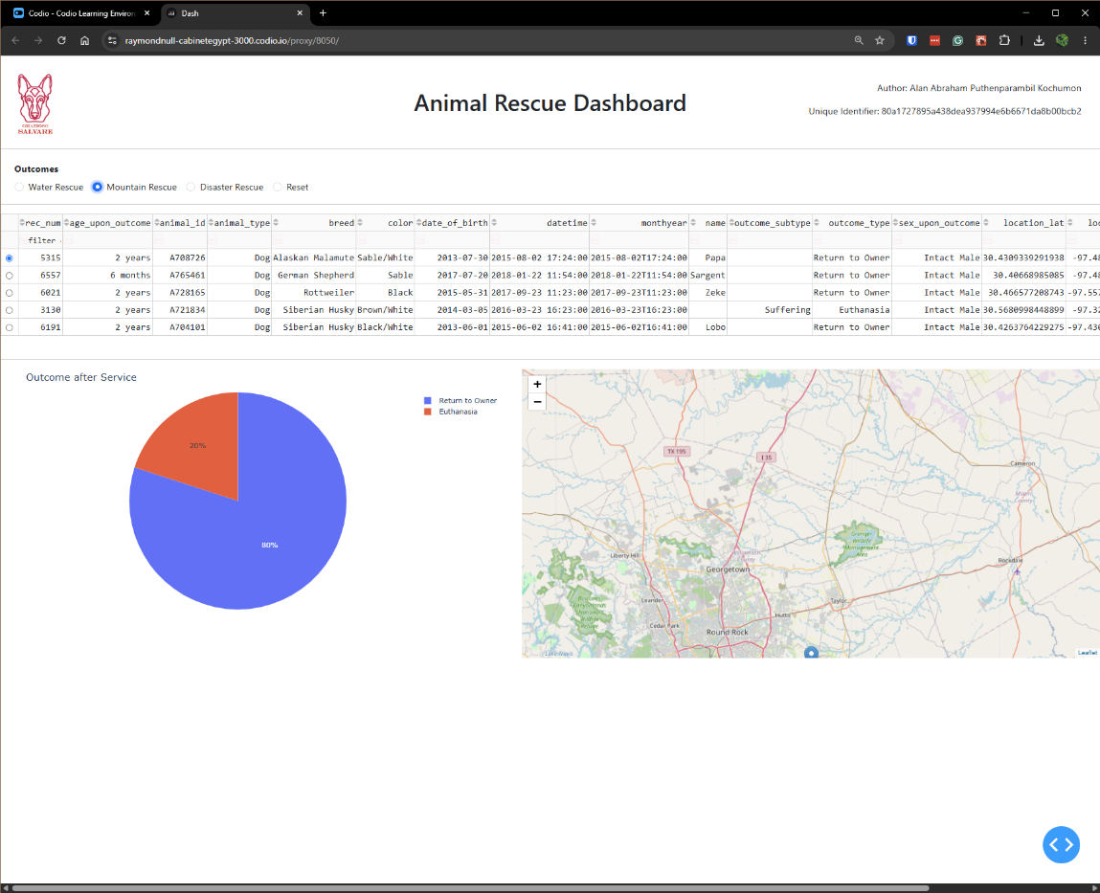
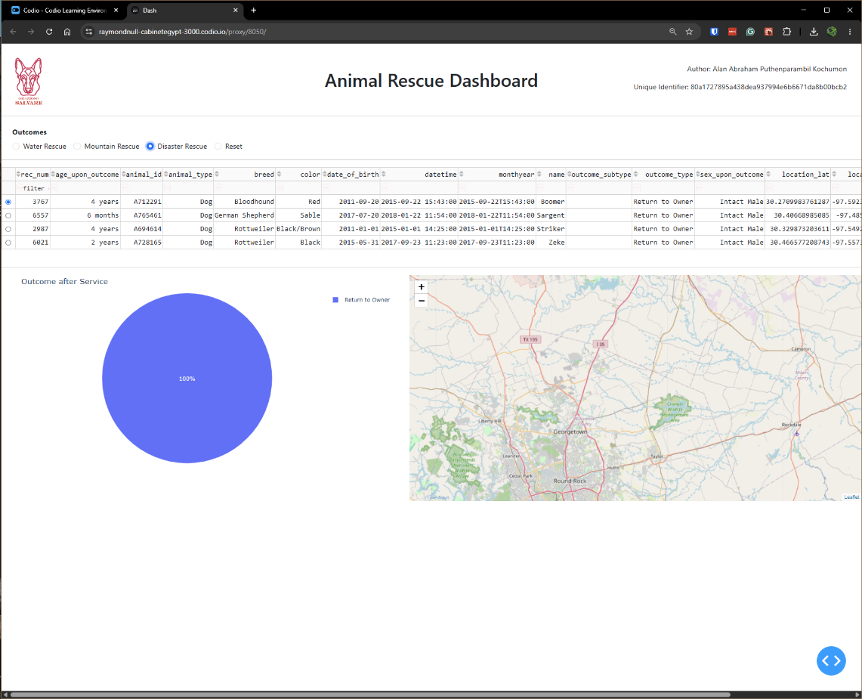

Steps Taken
The first step in this development lifecycle was to complete the MongoDB driver (the DAO) during Project One. This aimed to bridge the gap between direct MongoDB manipulation and Python using the official PyMongo driver. It encapsulates the inner workings and handles edge cases gracefully, providing a layer of abstraction and decoupling that allows the backend code to be updated without breaking the frontend.
The next step was to architect the frontend dashboard. To overcome the initial learning curve of Dash, I referenced external tutorials to understand component routing. Initially, it was unintuitive that callbacks are invoked indirectly via component IDs rather than direct function calls. I then applied a Bootstrap theme to modernize the UI. Finally, to ensure all client criteria were met, I performed manual testing on all interactive filtering and data rendering options.
Development Challenges & Solutions
During the development of the CRUD module's read method, a primary challenge involved handling return types from the PyMongo driver. Specifically, the `find()` method returns a MongoDB Cursor object rather than a usable Python list. I overcame this by explicitly casting the cursor to a list (list(result)) before returning it to the calling application. Additionally, to ensure application resilience, I implemented try/except blocks around database API calls to gracefully catch connection errors and return standardized fallbacks rather than crashing the downstream application.
Then, during the UI development, an accidental Dash version update broke the application, as the newer environment versions did not support the legacy code structure used in initial testing. I resolved this by rolling back the environment to a stable version compatible with Dash Bootstrap Components.
Moreover, due to the high density of categorical data in the initial dataset, the requested pie chart was rendering too small and becoming unreadable. I solved this UX issue by switching the chart's target metric to "Outcome After Service" (outcome_type), resulting in a much cleaner and more readable visualization for the end user.

Contact
Your name: Alan Abraham Puthenparambil Kochumon

